In this part of development, we will add the :
- background image
- create a sign in/login system
- add transparency to containers and recyclerviewer
- Add the tournaments info (main activity) and tournament fragment

background image :

The application will have a few different background images for :
- the signup process
- main activity
- player and tournament fragment fragments

For the login/signup page, add the gif here : https://www.pinterest.ca/pin/via-gifer--381891243410676198/ , in the background. Make sure that we can see correctly the image in the background

For the main activity, where there is the rankings and tournaments put « bg1 » in the background.

After the splash screen, instead of the snack bar that says loading players, put this gif https://www.hollysproull.com/gifs , above the raquet put a loading circle. Below the loading circle put « loading players ».

In the other fragments (players, tournaments, options) put the « bg2 » image in the background.

Sign-up /login system :

After the splash screen, when the application starts, there is the login page. The application requires that you log before you view the stats of the players.

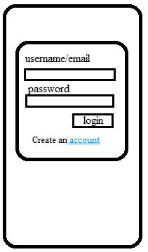

Do not forget to put the background image. Put the container transparent a little bit so that we see the background image. The login button in orange with white for the fonts.

The user can either enter his email or his username. The user will have to create an account to be able to access the app. He can click on the « account » in blue to create an account. He lands on this activity :
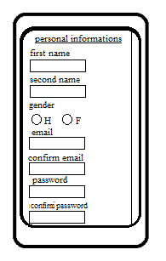

f

if you scroll down you see additional informations :

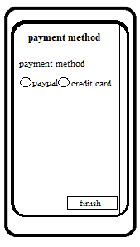

The user can add a payment method. He can also decide to skip this step by just clicking finish. If he clicks on paypal, a fragment appears above the screen to allow paypal connexion.

It should look like this :
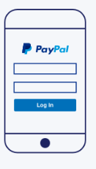
f

In the first field, put as hint email and below as hint password. Put the paypal logo on top with the word paypal. Put the pay in dark blue, and pal in sky-light blue.

When the user enters a right email (regex that must contains « @ » , « , » « . something » and put a password (above 8 letters) it will automatically work. You dont need to do a real paypal plugin.

Once the user clicks on login, the small paypal popup window dissapear, and there is a small snackbar at bottom with « payment method accepted ». then the radiobox of paypal stay checked.

If the user chooses a credit card, there will be a different pop up window that looks like that :

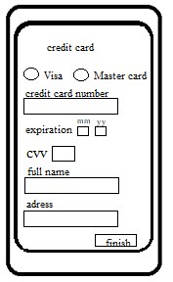
f

Here the user must choose either visa or mastercard. Next, he must enter a 12 digit number. Make sure the field only accept digits. Then he must enters the expiration date. There is two small fields. Make sure that the mm fields only accepts numbers from 01 to 12. For year make sure it accepts numbers from 19 to 30. If one of those fields has wrong number, make it in red.

Next, there is the cvv. Make sure its only a number with 3 digits. The user cannot input more than 3 digits.

Then the user can input his name and his adress. If one of those fields is not input correctly make a snack bar appears « some informations are missing ».

If you can find the icons for visa and master card and put them on the left of visa and mastercard. Once the user has finished inputting everything. On the left of the finish button add a button <<cancel>>, he will go back to the signin page. If all the informations are correct, he can press finish and he will get back to his signup page. A small bottom message will appear with « payment method accepted ».

He can then press finished. For the sign-up make sure all the fields are filled. If one field is missing, and he presses finish. A warning snackbar appear in the middle with « some informations are missing ». and put in red the fields that misses info.

The infos will be saved inside the firebase database as convened. Later, we will make an option fragment where the user will be able to change his payment method.

